**Information:**

For more information about the REMAP-CAP Trial at this hospital, please contact:

**Participating Hospital:**

*[Insert Contact Details]*

**Clinical Trial Manager:**

Janis Best-Lane

020 7594 9725

+44 (0) 7714 051 680

**Project Manager:**

Paul Mouncey

020 7831 6878

[ukremap-cap@ICNARC.org](mailto:SuDDICU@imperial.ac.uk)

The [*Insert site name]* Hospital/Intensive

Care Unit is participating in the REMAP-CAP Trial in Intensive Care Unit patients/ ward patients with COVID-19, influenza or pneumonia

**The ICU Research Coordinators**

*[Insert Contact Details]*

**The Principal Investigator**

The study is being sponsored by:

University Medical Centre Utrecht, Netherlands.

The UK Coordinating Centre is:

**Imperial College London / ICNARC**

**UK Coordinating Centre:**

**Contact details**

*[Insert Site LOGO]*





**Randomized, Embedded, Multifactorial Adaptive Platform trial for Community-Acquired Pneumonia**

**Registered on ClinicalTrials.gov:**

**NCT02735707**

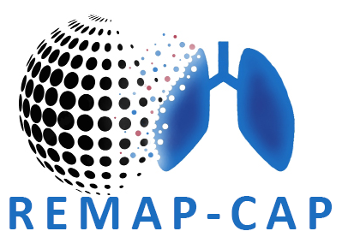

**Why is this study being done?**

**COVID-19, flu, and pneumonia** (lung infection) are all important current health problems.

Current treatments for these are based on previous research used in international guidelines that help doctors to choose the best care. As new treatments become available more research is needed to see whether there are better and more effective treatments.

The aim of this study is to investigate which treatments are best for patients admitted to hospital with COVID-19, flu, or pneumonia.

We are testing treatments in patients who have been admitted to the ward and / or the ICU.

The treatments for **COVID-19** are:

* simvastatin (reduces inflammation)
* low or a middle dose heparin (reduces blood clots)
* cysteamine (an antibacterial, antiviral and reduces inflammation).
* plasma therapy (blood antibodies from patients recovered from COVID-19).

[delete as appropriate]

The treatments for **flu** are:

* antiviral medications
* steroids [delete as appropriate]

The treatments for **other pneumonia** are:

* cysteamine
* steroids
* antibiotics which may help reduce inflammation. [delete as appropriate]

Not all treatments may be available at your hospital, your doctor will be able to tell you which treatments are available and best suited to you.  **Who will take part in this study?**

Patients who have been admitted to hospital or to ICU who have or are suspected to have COVID-19, flu or pneumonia. Only patients who meet the study criteria and are considered suitable by their treating doctor will be included. The treatments available are dependent on the severity of the condition and eligibility criteria.

The REMAP-CAP trial has already recruited over 11,000 patients globally over the past few years.

**What will happen during this study?**

Participation in this study is entirely voluntary. The doctor or researcher will explain the study and ask for your consent for participation. If you do not consent to participate in the study, no data will be collected from you.

You will then be randomised by a computer to one or more treatments. Depending on the treatment, a nasal swab and/or a blood sample will be taken. If you are randomised to receive a treatment you may receive this via an injection or a tablet.

**What about Confidentiality?**

The data gathered in this study will be kept strictly confidential at all times. Identifiable data will never leave the hospital.

**Why are the risks?**

All medical treatments can cause side effects. The risks and side effects are similar whether you choose to be in the study or not. A full list of side effects can be found on the participant information sheet from your doctor.