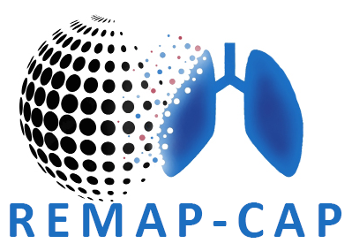

*Further information can be obtained about the* ***REMAP-CAP*** *trial from any member of the health care team.*

A research study looking at **the best treatments for COVID-19, flu and pneumonia (lung infection).**

COVID-19 is caused by a SARS-COV-2 virus and pneumonia can be caused by bacteria, or a virus like influenza (flu). If yourself, a friend or relative has been admitted to hospital with any of these health problems then they or you may be informed about taking part.

**Randomized, Embedded, Multifactorial Adaptive Platform trial for Community-Acquired Pneumonia**

