REMAP-CAP staff poster V1.0 01.02.2024

# REMAP-CAP

**TRIAL**

**A Randomised, Embedded, Multi-factorial,**

**Adaptive Platform** tr**ial for Community-Acquired Pneumonia**

***What REMAP-CAP has discovered so far:***

*Sarilumab , Tocilizumab & Corticosteroids reduce mortality and time in ICU for critically ill patients with COVID-19.*

**14,000**

**patients randomised worldwide!**

## Influenza

**domains**

### Influenza Antiviral

* + **Corticosteroid**
    - **Immune Modulation**

#### Other domains under investigation (COVID/CAP)

* + - **Antibiotics**
  + **Macrolide duration**

REMAP-CAP is currently open in ICUs and wards testing treatments for COVID-19, CAP and Influenza.

Adults and children admitted to hospital acutely unwell with confirmed influenza will be recruited to the trial.

#### Immunoglobulin

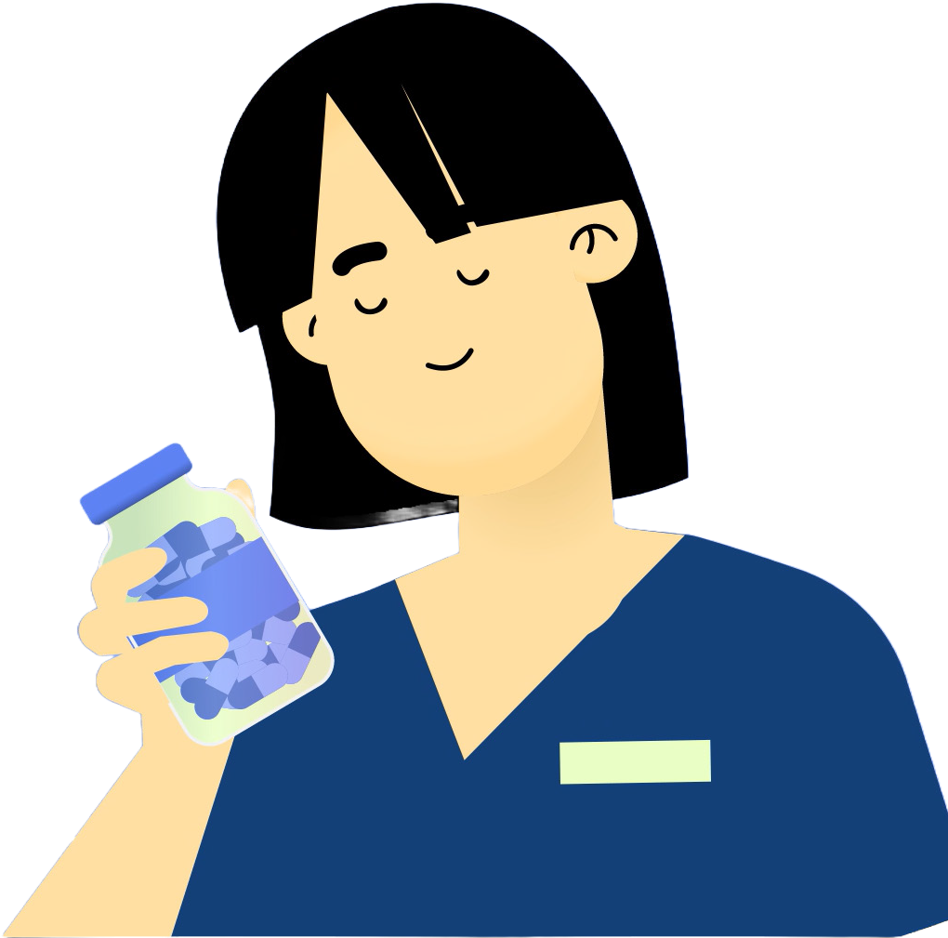

**Get in touch:**

For more information please feel free to contact us at: [ukremap-cap@icnarc.org](mailto:ukremap-cap@icnarc.org)

**Or speak to your local PI: Dr _____________**