**REMAP-CAP research**

**You are in hospital because your doctor thinks you are not very well because of an infection.**

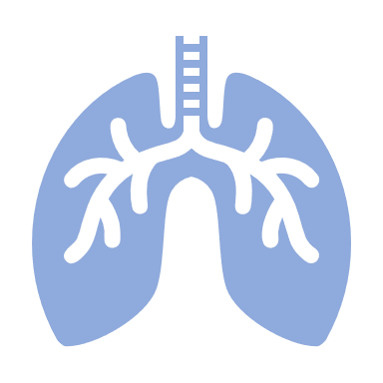

**If you have any questions, please ask your parents or your doctor and nurses.**

**We want to test some new treatments to make you and others like you feel better!**

**Infections can be caused by different things, one of these are viruses which can cause problems like coronavirus and flu.**