REMAP-CAP
Information Sheet and Consent Form
For parents/guardians/caregivers of children 10 to 15 years old (with capacity or now recovered capacity)

Please also provide the assent form to children who are aged 10 to 15 years old and are capable of giving their assent.

Invitation to the study

We are inviting people of any age who have been admitted to hospital with a respiratory tract infection (an infection that affects the nose, throat, airways or lungs) such as pneumonia, to participate in our research study. This can be caused by bacteria or viruses like flu (influenza). This study is trying to find the best treatments for these health problems. This form provides information about the study, the treatments we are using, and risks and benefits of taking part. We understand that having an infection can be very stressful. Take your time to read this information and feel free to discuss it with your family, partner, or friends.

What is the purpose of this study?

A respiratory tract infection is an important health problem. Although there are many different treatments currently used to treat patients with this, often doctors are unsure which option is best. As new treatments become available more research is also needed to see whether they work better. The aim of this study is to find out which treatments are best for patients who are seriously ill with this type of infection, to improve their chances of survival and recovery. REMAP-CAP is a worldwide study that has been active since 2016.

What treatments are being investigated?

When there is an infection, the immune system responds to fight the bacteria or virus (called ‘inflammation’). Sometimes, the immune system responds too much and this can lead to organ damage. We are studying the following treatments in patients who have been admitted to a hospital ward and/or an intensive care unit (ICU). Some of these treatments fight the bacteria or viruses directly, and the ‘anti-inflammatory’ treatments reduce an overactive immune response.

Corticosteroids are a type of anti-inflammatory medicine. The following treatments are being compared: dexamethasone (for up to 10 days) or no corticosteroids. These medications are given through a tube into your vein (drip) or as a tablet to swallow. Dexamethasone is authorised to be prescribed in children from 12 years old. For this study, it will be available for children who are younger, as we think it may work for them too.
Influenza (flu) antivirals are medicines that fight flu viruses. The following treatments are being compared: oseltamivir (a short or long course), baloxavir, the combination of both oseltamivir and baloxavir, or no antiviral. These medications are given as a tablet or liquid to swallow.

Immune modulators are medicines which help your immune system work properly and are found to be effective in infections such as COVID-19. They might work against flu but we do not know for sure. The following treatments for influenza (flu) are being compared: baricitinib, tocilizumab, or no immune modulator. These are given through a tube into your vein (drip) or as a tablet to swallow.

Outside of this study, the above treatments are authorised to be prescribed in your child’s age group 10-15 years old, except for Dexamethasone as described above.

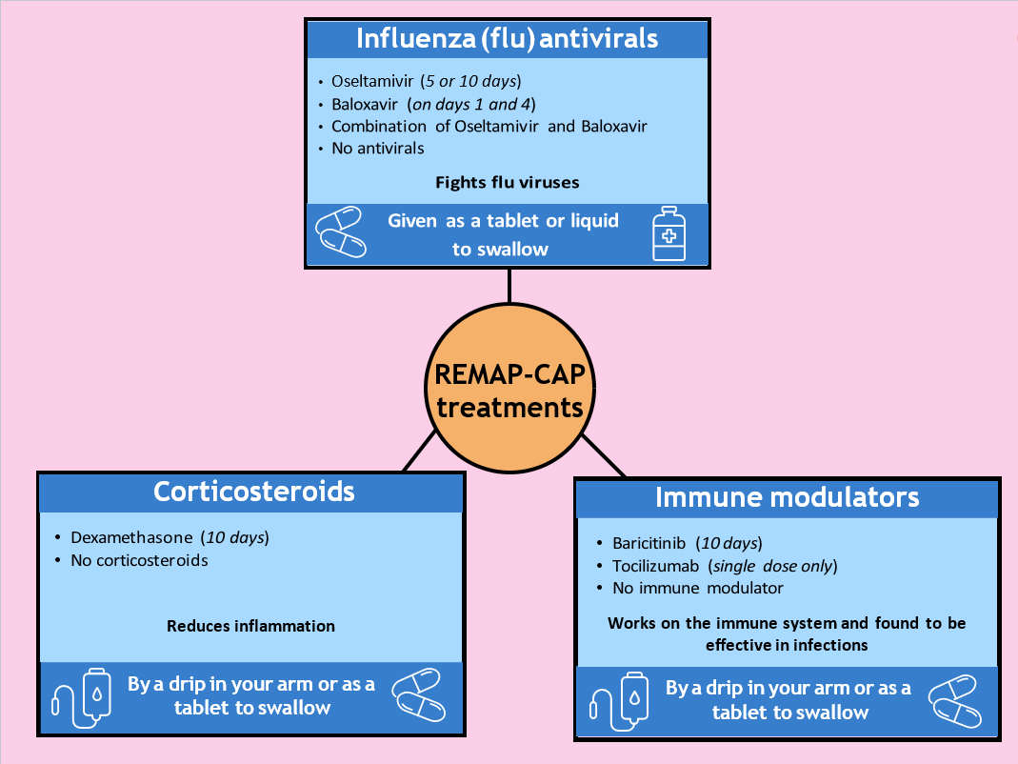

(please delete domain(s) and/or treatment(s) that the site is not participating in, in both text and chart above)

Your doctor will know which set of treatments are suited to your child in the study. We may use a combination of these treatments because it is important to understand which combinations are best. Many of these treatment comparisons also include a ‘no additional treatment’ option, so your child may not receive any of these treatments but will still receive standard of care at your hospital.

Who will be included in the study?

Patients who have been admitted to hospital or to ICU, who have or are suspected to have a respiratory tract infection (an infection that affects the nose, throat, airways or lungs) such as pneumonia or flu. Only patients who meet the study requirements and their doctor believes they are suitable will be included. The treatments available depend on how serious the condition is and whether the different treatments are suitable for your child.

What does participation in this study involve?

TYour doctor will always first decide if the study is best for your child and will always provide the healthcare your child requires.

It is important to start treatment of these conditions as quickly as possible. This is why some treatments may already have started before you were given this consent form. If you (or your child) were not able to give your consent/assent straight away, we asked your family member/friend or doctor for their consent to include your child in the study. This will only happen if your family member/friend or doctor is not aware of any previous reason that you (or your child) may not wish to participate in the trial. If a family member/friend is not available, an independent doctor or independent senior nurse can be asked to provide consent on your behalf. An independent doctor/senior nurse is not involved in the study. We always check if you are happy for your child to continue in the study once you are able to give your own consent.

In certain circumstances (such as isolation measures during a pandemic), it may not be possible to sign a consent form on paper, and we may ask you to provide verbal consent. Written consent will then be collected as soon as possible.

Participation is entirely voluntary. If you agree for your child to participate, we will ask you to sign a consent form. We will enter some details about your child and answer some medical questions on a computer. Your child will then be randomised by a computer to receive one or more of the above treatment options. Randomisation is a process like tossing a coin, and your child will have a chance of receiving one of the above treatment options in each group, which allows us to compare their treatment to others. The study looks at the results on an ongoing basis and uses these results to make some changes to the randomisation process with the aim of increasing the chances of getting treatments that are looking better for new patients in the study, but there is no guarantee.

Once your child has been randomised, depending on the treatment, a nose swab will be taken. Nose swabs will also be collected 3 and 7 days later. The doctor, nurse or researcher will explain the study to you/your child, but no one can choose which treatment your child will get. Even if your child is participating in the study, the study treatment will be adjusted or stopped if your doctor thinks it should be.

During the study, further information about your child’s health will be entered onto a computer. Once your child is discharged from hospital, no further hospital visits are required. We will contact you (or your child) 6 months later to complete a questionnaire about your child’s wellbeing, by telephone. To learn whether the treatments worked, we will collect information from your child’s medical records from before your child joined the study and up to 6 months later. We will also request information about your child from the following research databases: Intensive Care National Audit & Research Centre (ICNARC), NHS Digital, UK Health Security Agency, and genetic or other research databases (if you have provided your child’s information/samples to them). We will keep this information for up to 25 years after your child’s discharge. All data collected from your child will be pseudonymised, which means that your child’s name and other identifiers will be replaced by a reference number (code), so your child cannot be directly personally identified by this.

Are there any benefits in taking part?

This study will tell us if some treatments are better than others, but we cannot guarantee that taking part in the study will benefit your child directly. The findings may help improve treatment for people with a respiratory tract infection such as pneumonia or flu in the future.

If there is little difference between the treatments, then the benefit of being in the study will be less, but the disadvantages will still be minimal.

Are there any risks in taking part?

All medical treatments can have side effects, and these range from mild to serious. The side effects known for the treatments used in this study are described later in this form. The risks and side effects are similar whether you choose to be in the study or not. Your doctor will know what treatment you are receiving at all times and will be looking out for any side effects.

Pregnancy

Women who are pregnant or breastfeeding may be included depending on the type of treatment. Some treatments (e.g., baloxavir and baricitinib) have not been tested on pregnant women before, and the effect on unborn babies is uncertain, so those treatments may not be available. We have an expert group who review our safety results closely, and if there are any issues, your child’s treatment will be stopped immediately.

Can I stop/change my mind?

Whether your child takes part in the study is up to you/your child. If you no longer wish for your child to be part of this study, this is not a problem and they will not lose out. No further information will be collected about your child, and the doctors will continue to provide your child with standard medical treatment. You will have the option to allow us to continue to collect information about your child. Pseudonymised (coded) data about your child and samples that were already collected up to your withdrawal of consent will still be analysed by the study team unless you tell us that you do not want the data or samples already collected, to be used.

What if I have a problem or a question?

If you have any questions about the study, please reach out to your child’s medical team in the first instance. Their details are below:

Contact Name | Contact Number

Further information about the study can be found on our study website:
https://remapcap.co.uk/patients, via email: ukremap-cap@icnarc.org, or telephone: 0207 594 5906.

For independent research advice, please see the contact information below:

England/Wales sites only (delete if not applicable)

If you have any questions about your child being in a research study, you can contact the Trust’s Patient Advice Liaison Service (PALS). They will give you advice about who you can talk to for independent advice.

Local PALS office telephone number | Local PALS office address

Northern Ireland sites only (delete if not applicable)

If you have any questions about your child being in a research study, you can contact the person listed below. They will give you advice about who you can talk to for independent advice.

Local Contact | Local address

Scotland sites only (delete if not applicable)

If you have any questions about your child being in a research study, you can contact [insert full name] (contact details below) who is not involved in the study and will be able to give you independent advice.

[insert independent contact telephone number/email address/postal address]

You can also find more information about the study by searching for REMAP-CAP on the website www.ClinicalTrials.gov.

The trial sponsor is University Medical Center Utrecht (UMCU), who holds an insurance policy for this study (Allianz Global Corporate & Specialty, policy number: GBL00716220B). In the unlikely event that your child experiences serious and enduring harm or injury as a result of taking part in this study, you may be eligible to claim compensation without having to prove that UMCU is at fault. Not all damage is covered. This does not affect your legal rights to seek compensation. If your child is harmed due to someone’s negligence, then you may have grounds for legal action.

How do you use information about my child and how do you keep it private?

All information about your child, their health, and their participation will be kept private. The only people who will have access to this information are the doctors and nurses looking after your child and employees of the Sponsor UMC Utrecht, Imperial College London, and ICNARC who have authorisation. More information is available in our privacy notice on our website: https://remapcap.co.uk/patients. If you prefer, you can ask for a copy of it from your child’s medical team.

End of study

Your child’s participation in this study will stop if:

• The follow-up period for the study has been completed. This is either 90 days or 180 days after your child’s participation in the study (once you have been contacted by the research team to complete a questionnaire about your child’s wellbeing for the 6-month follow-up)
• You/your child decide to not take part anymore
• The Ethics Committee, government, or UMC Utrecht (study sponsor) decides to stop the study

The doctor or researcher will let you know if there is any new information about the study that is important to you/your child. They will then ask you/your child if you want to continue in the study, if your child is still receiving study treatment.

How do I find out the results?

You/your child will not be personally told about the results of the study. The results of this study will be presented at medical meetings and published in scientific journals. This will only involve anonymous group data, and no personal information will be presented. If you are interested in the results, they will be available on our EU website: https://www.remapcap.eu/

Who is funding it?

The Coordinating Principal Investigator for this study is Professor Marc Bonten, at the University Medical Center Utrecht, Netherlands. This research has received funding from Rapid European COVID-19 Emergency Research response (RECOVER) consortium by the European Union’s Horizon 2020 research and innovation programme (#101003589) and from the UK National Institute for Health and Care Research (NIHR). The cost of some treatments may be covered by companies that make these products. These companies are not involved in the design, analysis, or reporting of results from the trial.

The UK Principal Investigator is Professor Anthony Gordon at Imperial College London, and the UK Trial Coordinating Centre is ICNARC, Napier House, 24 High Holborn, London WC1V 6AZ.

Who has reviewed and approved it?

All research involving patients in the NHS is looked at by an independent group of people called a Research Ethics Committee. This study has been reviewed and approved by the London- Surrey Borders HRA Ethics Committee.

Informational video

Please feel free to watch a short video that summarises the study by scanning the QR code below with your phone’s camera:


List of common side effects of study medication

The below side effects are considered common for these treatments.

Dexamethasone can cause the following side effects: Fluid retention, abnormal appetite, high blood sugar levels, pain in muscles or joints, nausea, stomach pain, headache, dizziness, tingling in hands or feet, sleeping disorders, increased risk of infection, high blood pressure, and general state of discomfort (malaise).

Oseltamivir can cause the following side effects: Headache, nausea, vomiting, stomach pain, acid reflux, runny nose, dizziness, trouble sleeping, increased risk of infection, cough, sore throat, and general state of discomfort (malaise).

Baloxavir rarely causes side effects. No side effects are listed in the information about the medication, that occur in more than 1% of patients.

Baricitinib can cause the following side effects: Lung (respiratory tract) infections, herpes infections, urine infections, skin infections, infection of the intestines, abnormal laboratory results (such as high platelet count, high cholesterol, high liver enzymes, and high enzymes associated with muscle problems), headache, nausea, stomach pain and skin problems such as acne.

Tocilizumab can cause the following side effects: Lung (respiratory tract), skin, or urine tract infections, herpes infections, stomach problems (such as pain, inflammation, or constipation), mouth ulcers, abnormal laboratory results (such as low white blood cells, high cholesterol, high liver enzymes, and high bilirubin), headache, dizziness, eye inflammation, high blood pressure, weight gain, coughing, shortness of breath, swelling of hands and legs due to fluid build retention (peripheral oedema), and itchiness.

(please delete treatment(s) that the site is not participating in)

Besides the side effects mentioned above, all medications can cause rashes or allergic reactions and there are other side effects which are rare (these occur in less than 1% of people). Your doctor knows these side effects and will look out for them.

REMAP-CAP
Information for children 10 to 15 years old


We wish to tell you about our research study. You are in hospital because your doctor thinks you are not very well because of an infection. Infections can be caused by different things, and one of these are viruses which can cause problems like flu and pneumonia.

We want to test some new treatments that might make you and others like you feel better. Treatments change all the time and it is up to us to find out if there are better treatments that we can use to make people feel better quicker.

We are testing a few different treatments. We have listed these in more detail in a form for your parents or guardian and you can also have a copy if you like. The treatments include medicines for colds/flu, steroids which help reduce swelling in the body and other medicines that help your body fight bugs. All the treatments we are testing have been used before for other things in people your age, and we want to know if they also work for flu and pneumonia.

We are inviting young people like you who are admitted to hospital with an infection such as flu, to take part. Your doctor will tell you if you are suitable for our study and will let you and your parents or guardian know which treatments are available.

Your parents or guardian will talk to you and decide with you if you want to try these treatments as part of our study or if you don’t want to. If you and your parents or guardian decide to take part in our study, then this is what will happen next:

- Your doctor or nurse will explain the study to you
- We will enter your initials, your age, if you are a boy or girl, and information about your illness on our computers
- Our computer will then pick some treatments for you. This is done automatically, so we don’t know which ones will be chosen.
- Depending on which treatment you get, you may be asked to take a tablet or have an injection
- We may take some nose swabs (samples of your virus) from you, until you leave hospital
- Girls aged 10-15 years will have a urine test for pregnancy to make sure that nobody having a baby takes the medicine we are testing
- We will contact your parents or guardian 6 months later to see how you are
- We will collect data about you from other research databases
You may not feel better, but you are helping us learn if our treatments work or not.

There can be side effects to some of these treatments, for example feeling sick or getting a headache. These are like side effects you might have after taking other medicines. Your doctor will keep a close eye on you, and if they are worried about any side effects, they will stop the treatment.

You and your parents or guardian can decide to stop the treatment and stop being in the study whenever you like. If you do this, your doctors will continue to provide other treatments if you are still unwell.

If you and your parents or guardian are happy for you to take part, we will ask your parents to sign a consent form and for you to also sign an assent form to confirm you are happy.

If you have any questions, please ask your parents/guardian or your doctor and nurses. We also have a study website which has more information about our study: https://remapcap.co.uk/patients

We will keep all the information we collect about you private. Only the doctors and nurses looking after you and people who are running this study will see any of your information. We have more information about how we keep the information private on our website: https://remapcap.co.uk/patients

We will put the findings of the study on our EU website: https://www.remapcap.eu/. We will also present our study at medical meetings and in scientific journals. None of your personal information will be presented.

We have received money for this study from the European Union (Rapid European COVID-19 Emergency Research response -RECOVER) and from the UK National Institute for Health and Care Research (NIHR). The UK leader of the study is called Professor Anthony Gordon and he works at Imperial College London.

Before we can start a research study, we need permission from a separate committee. Our permission was given by the London - Surrey Borders HRA Ethics Committee. They checked our study plan and made sure we had the right paperwork and the right people to run the study.

CONSENT FORM FOR PARENTS/GUARDIANS/CAREGIVERS
OF CHILDREN AGED 10 TO 15 YEARS OLD

REMAP-CAP
Patient Study ID |  | Site #
Name of Principal Investigator
(use CAPITALS)

Please initial each box if you agree with the following:

I, (forename and surname)………………………………………………………………………………………………, freely agree for my child,
(your child’s forename and surname)………………………………………………………………………………………………, to take part in the study.

1. I confirm that I have read (or had read to me) and understood this patient information sheet for the above study and have been able to ask questions which have been answered fully.

2. I agree to for my child take part in the following domains:
corticosteroids, influenza (flu) antivirals, or immune modulators
(delete domain(s) that the site is not participating in)
(strike through domain(s) if the parent/guardian does not agree)

3. I understand that my child’s participation is voluntary, and we are free to withdraw consent for this at any time, without giving any reason, and without my child’s medical care or legal rights being affected.

4. I understand that my child’s identity will never be given to any third parties, and any information collected will remain confidential.

5. I agree that my child’s medical records and other personal data generated during the study may be looked at by representatives of the sponsor (UMC Utrecht), by people working on behalf of the sponsor, by representatives of regulatory authorities, ICNARC, and NHS Digital, where it is relevant to my child taking part in this research.

6. I agree that I will allow the researchers to decide how to use the results of this study.

7. I understand that I will be contacted by ICNARC or my local hospital in six months to answer questions about my child’s quality of life and wellbeing.

8. I understand that minimal randomisation data collected about my child will be transferred outside of the EEA where the privacy rules of the European Union do not apply. I understand that an equivalent level of protection will be ensured for my child’s data.
(Note: if this point is refused, the patient cannot be included in the trial)

9. I give consent for nose swabs collected from my child to be used to support other research or in the development of a new test, medication, or treatment by an academic institution or commercial company in the future, including those outside of the United Kingdom (which the sponsor - UMC Utrecht - has ensured to keep secure).

Parent/guardian/caregiver’s name: _________________________ Signature: ______________________

Consent date (dd/mmm/yyyy): / / Time: : (24hr)

To be completed by the impartial witness* in the event the patient (child) and/or parent/guardian/caregiver is competent but unable to read, or unable to sign or date the informed consent form.
I confirm that the patient information and informed consent have been accurately explained to the patient (child) and/or parent/guardian/caregiver, the informed consent has been apparently understood by the patient (child) and/or parent/guardian/caregiver, and the patient (child) and/or parent/guardian/caregiver has voluntarily agreed to consent to participate in the study.

Impartial witness’ name: _________________________ Signature: _______________________

*An impartial witness is independent of the study, who cannot be unfairly influenced by people involved with the study (e.g., an independent nurse or a patient visitor)

Date (dd/mmm/yyyy): / / Time: : (24hr)

To be completed by the delegated site staff obtaining consent
I hereby declare that I have provided complete and accurate information about the study, and I have answered all questions.
If new information becomes known during the study that could affect the consent for participation, I will inform the patient (child and/or parent/guardian/caregiver in good time.

Investigator name (or delegate): ____________________________Signature: _____________________

Date (dd/mmm/yyyy): / /

ASSENT FORM FOR CHILDREN WHO ARE 10 - 15 YEARS OLD

(to be completed by the child and their parent/guardian/caregiver)
REMAP-CAP
Child or young person (or if unable, parent on their behalf) to circle all they agree with:

Do you understand what this study is about? | Yes/No
Have you asked all the questions you want? | Yes/No
Do you understand the answers that were given to your questions? | Yes/No
Are you happy to take part? | Yes/No
If any answers are ‘no’ or you don’t want to take part, do not write your name below.

If you do want to take part, you can write your name below:

Your name: ___________________________________________

Date (day/month/year): ___________________________________________

The doctor or nurse who explained this study to you needs to sign too:

Print name: ___________________________________________

Sign: ___________________________________________

Date (dd/mmm/yyyy): ___________________________________________

Thank you for your help.
1 original copy for ISF; 1 copy for participant ; 1 copy for hospital notes.

To ensure confidence in the process and minimise risk of loss, all consent forms must be printed, presented, and stored in double sided format

