REMAP-CAP
Information Sheet and Consent Form
For parents/guardians/caregivers and young people aged 16 and 17 years old (with capacity or now recovered capacity)

To be provided to young people who are aged 16 and 17 and are capable of giving their consent. If not, to be provided to their parent/guardian/caregiver.

Invitation to the study

We are inviting people of any age who have been admitted to hospital with a respiratory tract infection (an infection that affects the nose, throat, airways or lungs) such as pneumonia, to participate in our research study. This can be caused by bacteria or viruses like flu (influenza). This study is trying to find the best treatments for these health problems. This form provides information about the study, the treatments we are using, and risks and benefits of taking part. We understand that having an infection can be very stressful. Take your time to read this information and feel free to discuss it with your family or friends.

Why are we running this study?

A respiratory tract infection is an important health problem. Although there are many different treatments currently used to treat patients with this, often doctors are unsure which option is best. As new treatments become available more research is also needed to see whether they work better. The aim of this study is to find out which treatments are best for patients who are seriously ill with a this type of infection, to improve their chances of survival and recovery. REMAP-CAP is a worldwide study that has been active since 2016. In the UK we are looking at the following treatments (for children) in the chart below, but not all of them may be available at this hospital:

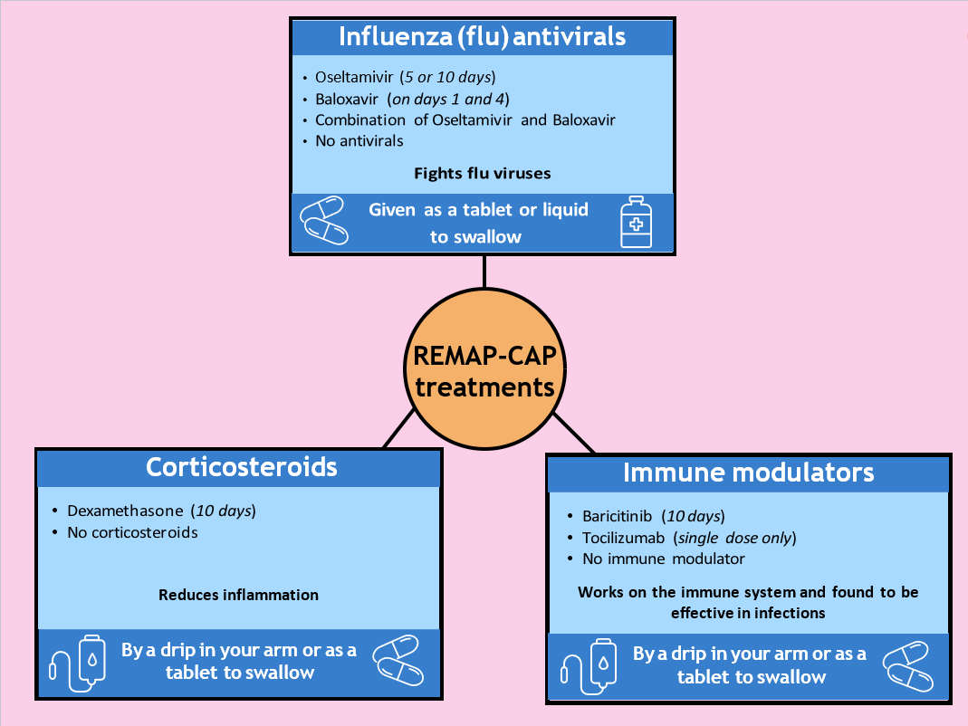

What study treatments are we testing at this hospital?

When there is an infection, the immune system responds to fight the bacteria or virus (called ‘inflammation’). Sometimes, the immune system responds too much and this can lead to organ damage. We are studying the following treatments in patients who have been admitted to a hospital ward and/or an intensive care unit (ICU). Some of these treatments fight the bacteria or viruses directly, and the ‘anti-inflammatory’ treatments reduce an overactive immune response.

Corticosteroids are a type of anti-inflammatory medicine.
☐We are not taking part at this hospital

The following treatments are being compared (those in bold):
- dexamethasone (for up to 10 days)
- no corticosteroids
These medications are given through a tube into your vein (drip) or as a tablet to swallow.

Influenza (flu) antivirals are medicines that fight flu viruses.
☐We are not taking part at this hospital

The following treatments are being compared (only those in bold):
- oseltamivir (a short or long course)
- baloxavir
- the combination of both oseltamivir and baloxavir
- no antiviral
These medications are given as a tablet or liquid to swallow.

Immune modulators are medicines which help your immune system work properly and are found to be effective in infections such as COVID-19. They might work against flu but we do not know for sure.
☐We are not taking part at this hospital

The following treatments for influenza (flu) are being compared (only those in bold):
- baricitinib
- tocilizumab
- no immune modulator
These are given through a tube into your vein (drip) or as a tablet to swallow.

Outside of this study, the above treatments are all authorised to be prescribed in your (or your child’s) age group 16-17 years old.

(please bolden treatment(s) that the site IS participating in, and/or tick as appropriate, in the text above)

Your doctor will know which set of treatments are suited to you (or your child) in the study. We may use a combination of these treatments because it is important to understand which combinations are best. Many of these treatment comparisons also include a ‘no additional treatment’ option, so you (or your child) may not receive any of these treatments but will still receive standard of care at your hospital.

Who will be included in the study?

Patients who have been admitted to hospital or to ICU, who have or are suspected to have a respiratory tract infection (an infection that affects the nose, throat, airways or lungs) such as pneumonia or flu. Only patients who meet the study requirements and their doctor believes they are suitable will be included. The treatments available depend on how serious the condition is and whether the different treatments are suitable for you (or your child).

What does participation in this study involve?

Your doctor will always first decide if the study is best for you (or your child) and will always provide the healthcare you (or your child) require.

It is important to start treatment of these conditions as quickly as possible. This is why some treatments may already have started before you were given this consent form. If you (or your child) were not able to give your consent straight away, we asked your family member/friend or doctor for their consent to include you (or your child) in the study. This will only happen if your family member/friend or doctor is not aware of any previous reason that you (or your child) may not wish to participate in the trial. If a family member/friend is not available, an independent doctor or independent senior nurse can be asked to provide consent on your (or your child’s) behalf. An independent doctor/senior nurse is not involved in the study. We always check if you are happy to continue in the study once you are able to give your own consent.

In certain circumstances (such as isolation measures during a pandemic), it may not be possible to sign a consent form on paper, and we may ask you to provide verbal consent. Written consent will then be collected as soon as possible.

Participation is entirely voluntary. If you agree to participate (or for your child to participate), we will ask you to sign a consent form. We will enter some details about you (or your child) and answer some medical questions on a computer. You (or your child) will then be randomised by a computer to receive one or more of the above treatment options. Randomisation is a process like tossing a coin, and you (or your child) will have a chance of receiving one of the above treatment options in each group, which allows us to compare your treatment to others. The study looks at the results on an ongoing basis and uses these results to make some changes to the randomisation process with the aim of increasing the chances of getting treatments that are looking better for new patients in the study, but there is no guarantee.

Once you (or your child) have been randomised, depending on the treatment, a nose swab might be taken. Nose swabs will also be collected 3 and 7 days later. The doctor, nurse or researcher will explain the study to you (or your child), but no one can choose which treatment you will get. Even if you (or your child) are participating in the study, the study treatment will be adjusted or stopped if your doctor thinks it should be.

During the study, further information about your (or your child’s) health will be entered onto a computer. Once you (or your child) are discharged from hospital, no further hospital visits are required. We will contact you (or your child) 6 months later to complete a questionnaire about your (or your child’s) wellbeing, by telephone. To learn whether the treatments worked, we will collect information about you (or your child) from your (or your child’s) medical records from before you (or your child) joined the study and up to 6 months later. We will also request information about you (or your child) from the following research databases: Intensive Care National Audit & Research Centre (ICNARC), NHS Digital, UK Health Security Agency, and genetic or other research databases (if you have provided your information/samples to them). We will keep this information for up to 25 years after your (or your child’s) discharge. All data collected from you (or your child) will be pseudonymised, which means that your (or your child’s) name and other identifiers will be replaced by a reference number (code), so you (or your child) cannot be directly personally identified by this.

Are there any benefits in taking part?

This study will tell us if some treatments are better than others, but we cannot guarantee that taking part in the study will benefit you (or your child) directly. The findings may help improve treatment for people with a respiratory tract infection such as pneumonia or flu in the future.

If there is little difference between the treatments, then the benefit of being in the study will be less, but the disadvantages will still be minimal.

Are there any risks in taking part?

All medical treatments can have side effects, and these range from mild to serious. The side effects known for the treatments used in this study are described later in this form. The risks and side effects are similar whether you choose to be in the study or not. Your doctor will know what treatment you are receiving at all times and will be looking out for any side effects.

Pregnancy

Women who are pregnant or breastfeeding may be included depending on the type of treatment. Some treatments (e.g., baloxavir and baricitinib) have not been tested on pregnant women before, and the effect on unborn babies is uncertain, so those treatments may not be available. We have an expert group who review our safety results closely, and if there are any issues, your (or your child’s) treatment will be stopped immediately.

Can I stop/change my mind?

Whether you (or your child) takes part in the study is up to you. If you no longer wish for you (or your child) to be part of this study, this is not a problem and you will not lose out. No further information will be collected about you (or your child), and the doctors will continue to provide you (or your child) with standard medical treatment. You will have the option to allow us to continue to collect information about you (or your child). Pseudonymised (coded) data about you (or your child) and samples that were already collected up to your withdrawal of consent, will still be analysed by the study team unless you tell us that you do not want the data or samples already collected, to be used.

What if I have a problem or a question?

If you have any questions about the study, please reach out to your (or your child’s) medical team in the first instance. Their details are below:

Contact Name | Contact Number

Further information about the study can be found on our study website:
https://remapcap.co.uk/patients, via email: ukremap-cap@icnarc.org, or telephone: 0207 594 5906.

For independent research advice, please see the contact information below:

England/Wales sites only (delete if not applicable)

If you have any questions about you (or your child) being in a research study, you can contact the Trust’s Patient Advice Liaison Service (PALS). They will give you advice about who you can talk to for independent advice.

Local PALS office telephone number | Local PALS office address

Northern Ireland sites only (delete if not applicable)

If you have any questions about you (or your child) being in a research study, you can contact the person listed below. They will give you advice about who you can talk to for independent advice.

Local Contact | Local address

Scotland sites only (delete if not applicable)

If you have any questions about you (or your child) being in a research study, you can contact [insert full name] (contact details below) who is not involved in the study and will be able to give you independent advice.

[insert independent contact telephone number/email address/postal address]

You can also find more information about the study by searching for REMAP-CAP on the website www.ClinicalTrials.gov.
The trial sponsor is University Medical Center Utrecht (UMCU), who holds an insurance policy for this study (Allianz Global Corporate & Specialty, policy number: GBL00716220B). In the unlikely event that you (or your child) experience serious and enduring harm or injury as a result of taking part in this study, you (or your child) may be eligible to claim compensation without having to prove that it was UMCU’s fault. Not all damage is covered. This does not affect your legal rights to seek compensation. If you (or your child) are harmed due to someone’s negligence, then you may have grounds for legal action.

How do you use information about me (or my child) and how do you keep it private?

All information about you (or your child), including health information and participation, will be kept private. The only people who will have access to this information are the doctors and nurses looking after you (or your child) and employees of the Sponsor UMC Utrecht, Imperial College London, and ICNARC who have authorisation. More information is available in our privacy notice on our website: https://remapcap.co.uk/patients. If you prefer, you can ask for a copy of it from your medical team.

End of study

Your (or your child’s) participation in this study will stop if:

• The follow-up period for the study has been completed. This is either 90 days or 180 days after your (or your child’s) participation in the study (once you have been contacted by the research team to complete a questionnaire about your or your child’s wellbeing for the 6-month follow-up)
• You/your child decide to not take part anymore
• The Ethics Committee, government, or UMC Utrecht (study sponsor) decides to stop the study

The doctor or researcher will let you know if there is any new information about the study that is important to you (or your child). They will then ask if you want to continue in the study, if you (or your child) are still receiving study treatment.

How do I find out the results?

You (or your child) will not be personally told about the results of the study. The results of this study will be presented at medical meetings and published in scientific journals. This will only involve anonymous group data, and no personal information will be presented. If you are interested in the results, they will be available on our EU website: https://www.remapcap.eu/

Who is funding it?

The Coordinating Principal Investigator for this study is Professor Marc Bonten, at the University Medical Center (UMC) Utrecht, Netherlands. This research has received funding from the Rapid European COVID-19 Emergency Research response (RECOVER) consortium by the European Union’s Horizon 2020 research and innovation programme (#101003589) and from the UK National Institute for Health and Care Research (NIHR). The cost of some treatments may be covered by companies that make these products. These companies are not involved in the design, analysis, or reporting of results from the trial.

The UK Principal Investigator is Professor Anthony Gordon at Imperial College London, and the UK Trial Coordinating Centre is ICNARC, Napier House, 24 High Holborn, London WC1V 6AZ.

Who has reviewed and approved it?

All research involving patients in the NHS is looked at by an independent group of people called a Research Ethics Committee. This study has been reviewed and approved by the London - Surrey Borders HRA Ethics Committee.

Informational video

Please feel free to watch a short video that summarises the study by scanning the QR code below with your phone’s camera:


List of common side effects of study medication

The below side effects are considered common for these treatments.

Dexamethasone can cause the following side effects: Fluid retention, abnormal appetite, high blood sugar levels, pain in muscles or joints, nausea, stomach pain, headache, dizziness, tingling in hands or feet, sleeping disorders, increased risk of infection, high blood pressure, and general state of discomfort (malaise).

Oseltamivir can cause the following side effects: Headache, nausea, vomiting, stomach pain, acid reflux, runny nose, dizziness, trouble sleeping, increased risk of infection, cough, sore throat, and general state of discomfort (malaise).

Baloxavir rarely causes side effects. No side effects are listed in the information about the medication, that occur in more than 1% of patients.

Baricitinib can cause the following side effects: Lung (respiratory tract) infections, herpes infections, urine infections, skin infections, infection of the intestines, abnormal laboratory results (such as high platelet count, high cholesterol, high liver enzymes, and high enzymes associated with muscle problems), headache, nausea, stomach pain and skin problems such as acne.

Tocilizumab can cause the following side effects: Lung (respiratory tract), skin, or urine tract infections, herpes infections, stomach problems (such as pain, inflammation, or constipation), mouth ulcers, abnormal laboratory results (such as low white blood cells, high cholesterol, high liver enzymes, and high bilirubin), headache, dizziness, eye inflammation, high blood pressure, weight gain, coughing, shortness of breath, swelling of hands and legs due to fluid build retention (peripheral oedema), and itchiness.

Besides the side effects mentioned above, all medications can cause rashes or allergic reactions and there are other side effects which are rare (these occur in less than 1% of people). Your doctor knows these side effects and will look out for them.


CONSENT FORM FOR YOUNG PEOPLE AGED 16 TO 17 AND ARE CAPABLE
OR THEIR PARENT/GUARDIAN/CAREGIVER

REMAP-CAP
Patient Study ID |  | Site # | (add number/name)
Name of Principal Investigator  (use CAPITALS) | add

Please initial each box if you agree with the following:

If the patient is capable:

I, (forename and surname)………………………………………………………………………………………………, freely agree to take part in the study.

If the patient is NOT capable:

I, (forename and surname)………………………………………………………………………………………………, freely agree for my child,

(your child’s forename and surname)………………………………………………………………………………………………, to take part in the study.

1. I confirm that I have read (or had read to me) and understood this patient information sheet for the above study and have been able to ask questions which have been answered fully.

2. I agree to (or for my child to)take part in the following domains:
corticosteroids, influenza (flu) antivirals, or immune modulators
(strike through domain(s) if the patient (child) or parent/guardian/caregiver does not agree)

3. I understand that my (or my child’s) participation is voluntary, and I am free to withdraw at any time, without giving any reason, and without my (or my child’s) medical care or legal rights being affected.

4. I understand that my (or my child’s) identity will never be given to any third parties, and any information collected will remain private.

5. I agree that my (or my child’s) medical records and other personal data generated during the study may be looked at by representatives of the sponsor (UMC Utrecht), by people working on behalf of the sponsor, by representatives of regulatory authorities, ICNARC, and NHS Digital, where it is relevant to my (or my child) taking part in this research.

6. I agree that I am happy for the researchers of this trial to decide how to use the results of this study.

7. I understand that I will be contacted by ICNARC or my local hospital in six months to answer questions about my (or my child’s) quality of life and wellbeing.
8. I understand that minimal randomisation data collected about me (or my child) will be transferred outside of the EEA where the privacy rules of the European Union do not apply. I understand that an equivalent level of protection will be ensured for my (or my child’s) data.
(Note: if this point is refused, the patient cannot be included in the trial)

9. I give consent for nose swabs collected from me (or my child) to be used to support other research or in the development of a new test, medication, or treatment by an academic institution or commercial company in the future, including those outside of the United Kingdom (which the sponsor - UMC Utrecht - has ensured to keep secure).

Patient (child’s) name (if capable): _________________________ Signature: ______________________

Parent/guardian/caregiver’s name
(if the patient is not capable) : _________________________ Signature: ______________________

Consent date (dd/mmm/yyyy): / / Time: : (24hr)

To be completed by the impartial witness* in the event the patient (child) and/or parent/guardian/caregiver is competent but unable to read, or unable to sign or date the informed consent form.
I confirm that the patient information and informed consent have been accurately explained to the patient (child) and/or parent/guardian/caregiver, the informed consent has been apparently understood by the patient (child) and/or parent/guardian/caregiver, and the patient (child) and/or parent/guardian/caregiver has voluntarily agreed to consent to participate in the study.

Impartial witness’ name: _________________________ Signature: _______________________

*An impartial witness is independent of the study, who cannot be unfairly influenced by people involved with the study (e.g., an independent nurse or a patient visitor)

Date (dd/mmm/yyyy): / / Time: : (24hr)

To be completed by the delegated site staff obtaining consent

I hereby declare that I have provided complete and accurate information about the study, and I have answered all questions.
If new information becomes known during the study that could affect the consent for participation, I will inform the patient (child) and/or parent/guardian/caregiver in good time.

Investigator name (or delegate): ____________________________Signature: _____________________
Date (dd/mmm/yyyy): / /

1 original copy for ISF; 1 copy for participant; 1 copy for hospital notes

To ensure confidence in the process and minimise risk of loss, all consent forms must be printed, presented, and stored in double sided format

