REMAP-CAP
Video Consent Form
For parents/guardians/caregivers and young people aged 16 and 17 years old
with capacity or now recovered capacity

Consent video

We are inviting people who have been admitted to hospital with a respiratory tract infection (an infection that affects the nose, throat, airways or lungs) such as pneumonia, to participate in our research study. This can be caused by bacteria or viruses like flu (influenza). We have generated a video which provides information about the study, the treatments we are using, and risks and benefits of taking part. Once you have watched the video and are happy to continue, please review and sign this consent form. You will also be provided with a full information sheet and privacy notice. This information is also available on our website: https://remapcap.co.uk/patients

You can watch the video by scanning the QR code below with your phone’s camera (or the doctor/nurse will open it on another device for you):
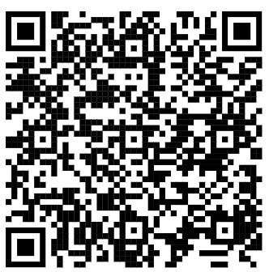

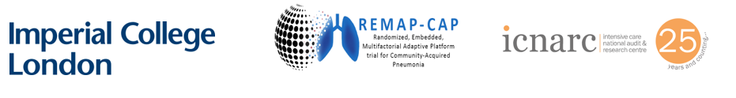
CONSENT FORM FOR YOUNG PEOPLE AGED 16 TO 17 AND ARE CAPABLE
OR THEIR PARENT/GUARDIAN/CAREGIVER
(WITH CAPACITY or now RECOVERED CAPACITY)
REMAP-CAP

Patient Study ID |  | Site # | (add number/name)
Name of Principal Investigator  (use CAPITALS) | (add name)

Please initial each box if you agree with the following:

If the patient is capable:

I, (forename and surname)………………………………………………………………………………………………, freely agree to take part in the study.

If the patient is NOT capable:

I, (forename and surname)………………………………………………………………………………………………, freely agree for my child,

(your child’s forename and surname)………………………………………………………………………………………………, to take part in the study.

1. I confirm that I have read (or had read to me) and understood this patient information sheet for the above study and have been able to ask questions which have been answered fully.

2. I agree to (or for my child to) take part in the following domains:
corticosteroids, influenza (flu) antivirals, or immune modulators
(delete domain(s) that the site is not participating in)
(strike through domain(s) if the patient does not agree)

3. I understand that my (or my child’s) participation is voluntary, and I am free to withdraw at any time, without giving any reason, and without my (or my child’s) medical care or legal rights being affected.

4. I understand that my (or my child’s) identity will never be given to any third parties, and any information collected will remain private.

5. I agree that my (or my child’s) medical records and other personal data generated during the study may be looked at by representatives of the sponsor (UMC Utrecht), by people working on behalf of the sponsor, by representatives of regulatory authorities, ICNARC, and NHS Digital, where it is relevant to my (or my child) taking part in this research.

6. I agree that I am happy for the researchers of this trial to decide how to use the results of this study.
7. I understand that I will be contacted by ICNARC or my local hospital in six months to answer questions about my (or my child’s) quality of life and wellbeing.

8. I understand that minimal randomisation data collected about me (or my child) will be transferred outside of the EEA where the privacy rules of the European Union do not apply. I understand that an equivalent level of protection will be ensured for my (or my child’s) data.
(Note: if this point is refused, the patient cannot be included in the trial)

9. I give consent for nose swabs collected from me (or my child) to be used to support other research or in the development of a new test, medication, or treatment by an academic institution or commercial company in the future, including those outside of the United Kingdom (which the sponsor - UMC Utrecht - has ensured to keep secure).

Patient’s name (if capable): _________________________ Signature: ______________________

Parent/guardian/caregiver’s name
(if the patient is not capable) : _________________________ Signature: ______________________

Consent date (dd/mmm/yyyy): / / Time: : (24hr)

To be completed by the impartial witness* in the event the patient/parent/guardian/caregiver is competent but unable to read, or unable to sign or date the informed consent form.

I confirm that the patient information and informed consent have been accurately explained to the patient/parent/guardian/caregiver, the informed consent has been apparently understood by the patient/parent/guardian/caregiver, and the patient/parent/guardian/caregiver has voluntarily agreed to consent to participate in the study.

Impartial witness’ name: _________________________ Signature: _______________________
*An impartial witness is independent of the study, who cannot be unfairly influenced by people involved with the study (e.g., an independent nurse or a patient visitor)

Date (dd/mmm/yyyy): / / Time: : (24hr)

To be completed by the delegated site staff obtaining consent

I hereby declare that I have provided complete and accurate information about the study, and I have answered all questions.
If new information becomes known during the study that could affect the consent for participation, I will inform the patient/parent/guardian/caregiver in good time.

Investigator name (or delegate): ____________________________ Signature: _____________________

Date (dd/mmm/yyyy): / /
1 original copy for ISF; 1 copy for participant; 1 copy for hospital notes
To ensure confidence in the process and minimise risk of loss, all consent forms must be printed, presented, and stored in double sided format

