Information:

For more information about the REMAP-CAP Trial at this hospital, please contact:
The [Insert site name] Hospital/Intensive
Care Unit is participating in the REMAP-CAP Trial in Intensive Care Unit patients and/or ward patients who have COVID-19, influenza or pneumonia.

The ICU Research Coordinators
[Insert Contact Details]
The study is being sponsored by:
University Medical Centre Utrecht, Netherlands.

The UK Coordinating Centre is:
Imperial College London / ICNARC

The Principal Investigator
[Insert Contact Details]

[Insert Site LOGO]

Participating Hospital:

UK Coordinating Centre:

Randomized, Embedded, Multifactorial Adaptive Platform trial for Community-Acquired Pneumonia

Registered on ClinicalTrials.gov:

NCT02735707

Clinical Trial Manager:
Aisha Anjum
+44 (0) 7956 800722

ukremap-cap@ICNARC.org

Contact details
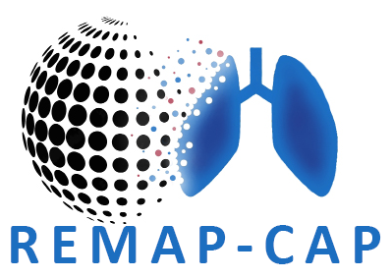
At this hospital
(delete as appropriate)

What will happen during this study?
Taking part in this study is entirely voluntary. The doctor or researcher will explain the study and ask for consent. If you do not consent to take part in the study, no data will be collected about you.
If you do take part, you will be randomised (randomly selected) by a computer for one or more treatment options.
Depending on the treatment, a nose swab and/or a blood sample will be taken. If you are randomised to receive a medication, you may be by an injection or tablet(s).
What about Confidentiality?
The data gathered in this study will be kept strictly confidential at all times. Identifiable data will never leave the hospital.
What are the risks?
All medical treatments can cause side effects. The risks and side effects are similar whether you choose to be in the study or not. A full list of side effects can be found on the participant information sheet given to you by your doctor.
Why is this study being done?
The treatments for flu are:
- antivirals
- immune modulators
- steroids
The treatments for COVID-19 are:
- immunoglobulin therapy (adults only)
The treatments for other pneumonia are:
- antibiotics (adults only)
- macrolides (adults only)
- steroids
Not all treatments may be available at your hospital, your doctor will be able to tell you which treatments are available and suited to you.
Who can take part in this study?
Adults and children who have been admitted to hospital or to the ICU and suspected or confirmed to have COVID-19, flu or pneumonia, can take part.
Only patients who meet the study criteria and are considered suitable by their treating doctor will be asked to participate.
The treatments available depend on how severe the condition is and eligibility criteria for treatments.
COVID-19, flu, and pneumonia (lung infections) are all important current health problems.
Current treatments for these are based on previous research used in international guidelines that help doctors to choose the best care. As new treatments become available more research is needed to see whether there are better and more effective treatments.
The aim of this study is to investigate which treatments are best for patients admitted to hospital with COVID-19, flu, or pneumonia.
We are testing treatments in adults and children who have been admitted to the ward and / or the ICU.

The REMAP-CAP trial has already had over 15,000 patients take part globally in the past few years.

